University of Pittsburgh’s
Pitt’s Kids 2025

Parent Handbook

Contents
What is Pitt’s Kids: 3
Summer 2025 Dates & Times: 4
Pre & Post- Care Procedures: 5
What to Bring to Camp: 6
Lunch Protocol: 6
Swimming Level Descriptions: 7
Gym Description & Groupings: 8
Policies: 9
Camper Drop-off & Pick-up Information: 10
Drop-off & Pick-up Location: 11

What is Pitt’s Kids:
Pitt’s Kids is the oldest community outreach program at the University of Pittsburgh. The program is sponsored by the School of Education at the University. The program is held at Trees Hall which serves as a perfect vehicle for the program.

The facility offers a 50-meter pool, 25-yard pool, rock wall, dance studio, 3 large basketball courts, racquetball courts, and a multipurpose room. This is perfect for the diverse activities that we offer at our program. We believe that every child should be exposed to as many activities as possible (some new, some old) to expand their interests.

In the morning portion of Pitt’s Kids’ program provides instruction in aquatics, games, and sports instruction to children ages 5-16 years old. Pitt’s Kids is comprised of two parts: 50 min. of physical activity and 50 min. of aquatic instruction. Games and Sports Instruction in the gym and Aquatic Instruction in the pool. This year we are adding a CIT program for ages 14-16 years old!

In-between both the morning and afternoon sessions age groups will walk to Sutherland Hall to eat lunch as a group. The lunch will be nut free and provided by the University Vendor services.
In the afternoon each age group will be together as they participate in fun camp activities. Activities will range from games in the gym, pool, crafts, experiments, scavenger hunts around the building, outside play time, and more.

Contact Information
Cécile Garfunkel
Director Community Leisure Learn Program
Cllprog@pitt.edu
412-648-8278
140 Trees Hall, Allequippa & Darragh Street
Pittsburgh, PA, 15261
Website: www.education.pitt.edu/cll

Summer 2025 Dates & Times:

Session dates:
Session 1: June 23rd- July 3rd (Monday-Thursday Program)
Session 2: July 7th - July 17th (Monday – Thursday Program)
Session 3: July 21st – July 31st (Monday – Thursday Program)

Session times:
5 through 16-Year-Old Program – 9:00am – 3:30pm.
(Drop off will begin at 9:00am-9:15am, and pick up begins at 3:15pm-3:30pm)

Pre-Care Program- 8:00am – 9:00am.
(Drop off will begin at 8:00am.) This is an additional fee.

Post-Care Program – 3:30pm – 5:30pm.
(Pick up during post-care is anytime between 3:30pm-5:30pm.) This is an additional fee.

Pre & Post- Care Procedures:
Pitt’s Kids is offering Pre & Post-Care options for families this coming summer. It will be supervised by Pitt’s Kids staff. Kids will participate in semi-structured activities with others that are in attendance. Activities will include but not limited to crafts, sport games, reading, and more.

Pre-Care:
Children that enroll in pre-care will report each day between 8am – 9am to the designated classroom where staff will take attendance each morning. At 9am staff will take the participants to either the pool balcony or to the gym for their first activity period of the program.

Pre-Care - $25 per session, per child.

Post- Care:
Children who are enrolled in post-care will be taken to the DANCE studio, located in Trees Hall at 3:30pm following the end of camp. Any child that has not been picked up by 3:30pm will automatically be enrolled into post-care. Post-care ends at 5:30pm each day. Families that do not pick up prior to 5:30pm will be charged an extended hour’s rate.

During this period participants will be given a snack provided by the camp. If a family wishes to pack a snack for their child that is accepted however, it can’t contain nuts.

Post-Care - $75 per session, per child.
Extended Day Charge - $5 every 5 minutes past 5:30pm.
If a child is not picked up by 3:30pm they will be enrolled in post-care and families will be charged $50 for that session.
If a child is not picked up by 5:30pm there will be an extended hour’s charge of $5 every 5 minutes past the 5pm time.

What to Bring to Camp:
Each day campers will want to bring/pack the following items to ensure they have a safe & fun time at our PK Summer camp.

Gym/Activity Attire:
Participants must wear closed toe sneakers or running shoes for the gym activities. NO Flip flops, sandals, or open-faced shoes and or heels Active Wear (shorts, t-shirts, socks) Bring a water bottle. Change of clothes (preferably another set of activity clothing.)
We try to go outside as much as possible. Families can pack sunscreen for their child. We will have child safe sunscreen as well.

Swimming Attire:
A bathing suit and towel each day.
Flip Flops for the pool deck are recommended but not required.
Googles and swim cap are recommended but no required. A change in clothing preferably active wear.

We ask that you don’t send your child with toys or any other games for the program unless directed otherwise. If you have further questions about what to bring to camp each day, please direct your questions to Cécile Garfunkel at this time.

Lunch Protocol:
Pitt’s Kids Summer Camp offers lunch for its campers in the 5 – 16-year-old age groups. Lunch will be held at Sutherland Hall between 11:45am and 12:45pm each day. Staff will walk each age group down to Sutherland Hall.

At lunch our staff will eat with their groups and spend time mentoring their groups. PK works with the University Vendors to provide an age-appropriate menu that is nut free and healthy. We don’t serve soda at our camp.

Parents will receive a menu prior to each session. If there are food restrictions, we work with the vendor to provide a healthy alternative for that child.

Swimming Level Descriptions:
Level I (Water Exploration):
For the beginner swimmer with little or no experience, who is comfortable holding onto the wall and using flotation devices independently. This level will work on the child’s independent entry and exit from the water, jumping into the water, swimming underwater, and proper kicking technique for the beginning of crawl strokes and breaststroke using flotation devices and learning arm motions for the strokes.
Level II (Primary Skills):
In this level the child should be able to submerge underwater and feel comfortable in the pool environment. This level will work on learning to swim and float short distances independently on their back and belly, and longer distances without support of a flotation device. The child will have more instruction to the swim strokes in this level and will learn to use arms and legs at the same time during these strokes.
Treading will be introduced as well.
Level III (Stroke Readiness):
The child should be able to retrieve objects underwater with eyes open, jump from the side of the pool into deep water and return to the side of the pool independently. This level the child will work on diving, refinement of stroke skills and swimming longer distances on his/her front and back.
Level IV (Stroke Development):
The child should be able to swim 25 yards of freestyle and backstroke, dive from the side of the pool, and tread water for 2 minutes. This level will work on front crawl with rotary breathing, learning the dolphin kick and side stroke, along with refinement of other strokes and increasing swimming endurance. The child will also work on retrieving objects from deeper water.
Level V (Stroke Refinement):
The child should be able to dive from a diving board, swim freestyle and backstroke uninterrupted for 50 yards, and breaststroke for 25 yards. This level will work on refining the four strokes; in particular the butterfly and breast strokes and begin swimming longer distances. The child will also begin to work on flip turns.
Level VI (Skill Proficiency):
The child will be proficient with all the major strokes and can swim 100 yards of freestyle and backstroke, 50 yards of breaststroke, and 25 yards of butterfly. The child should also be able to perform a flip turn or touch turn. This level will mainly continue the stroke refinement that began at the prior level, with a focus on increasing endurance.

Gym Description & Groupings:
5 & 6 years old:
Develop and refine fundamental motor patterns through game play. Including locomotor (i.e. running, skipping, galloping, jumping) and object control concepts (kicking, throwing, catching. striking). In addition, children in this age group will learn creative movement skills such as dance, creative acting, language, and academic development. For this age group there will be feature activities in cooperative learning to support relationship development.
7 – 9 years old:
Develop and advance activity and sport concepts through game play. An emphasis will be placed on learning tactical strategies for offensive and defensive games, sportsmanship, communicating and listening, health benefits, and cooperation. Activity categories include (invasion, catching and throwing, fielding, and striking, and aerobic tag games). In addition, fundamental skills for rock wall climbing and high energy dance will be taught.
10 to 13 years old:
Develop and refine activity and sport concepts through game play. An emphasis will be placed on learning new and innovative games and sports. This includes games like catchhit (paddleball and lacrosse), boccerball (basketball & soccer) and angleball (target and conditioning game). In addition, an emphasis will be placed on reinforcing sportsmanship, communication, and relationship development.

14 to 16 years old: NEW
This summer we are offering a new Counselor in Training (CIT) program for ages 14-16, where CIT participants gain valuable mentoring experience by connecting with campers and enhancing their skills through specialized instruction in swimming and gym activities. Each day consists of 50 minutes of physical activity followed by 50 minutes of aquatic instruction, providing a well-rounded experience in both the gym and pool. Children in this age group will have been taught how to safely and effectively use to muscle fitness equipment.

Policies:

Communication with Parents
We communicate with parents via email, and our website. In the application, please list an email that you or your family will check for updates regarding the program. Below is a list of resources on the Internet.

Website: www.education.pitt.edu/cll

Refund Policy:
Families have until one week prior to the start of the summer camps to request a refund partial refund. If the refund request prior to June 20th that family will receive full amount minus the registration fee of $25 per child.

Pitt’s Kids DOESN’T offer refunds and or pre-rated rates during the start of the program. If your child misses a day or there is a scheduling conflict, we will not offer a refund or pro-rated amount. If the University were to cancel programs due to a pandemic, we would offer full refunds for those families enrolled.

Behavioral Policy:
Our top priority is to provide a safe and enriching experience for all children. To do this, we must work together to develop the best plan for each individual child. To ensure this positive environment, we may not be able to serve children who repeatedly display disruptive behavior. Disruptive behavior is defined as verbal, physical or sexual misconduct which requires constant attention from the staff including, but not limited to hitting, kicking, spitting, and attempting to leave the program space, hostile verbal behavior, and other behaviors which may hurt another child, themselves, or staff member.

Program Expectations:
Respect others, the environment, and yourself
Use put ups, not put downs
Honesty
Be responsible for yourself
Treat others as they would like to be treated

In Response to Misbehavior:
Be consistent in enforcing rules
Using positive language Give clear choices Redirect your child
Respect your child
Work with parents to create and implement effect plans.

Our goal is to work together with the child and family to address and modify any behavior concerns; however, if a child cannot display appropriate behavior, then he/she may be removed from the program.

Camper Drop-off & Pick-up Information:
We follow a strict arrival and dismissal system to ensure your child’s safety! So please read the procedures carefully. This process is for all campers, ages 5-16.

Arrival time- is between 9:00 – 9:15AM - with children’s program starting right at 9:15am.

Dismissal Time- is between 3:15pm – 3:30pm.

If a child is not picked up by 3:30pm they will be enrolled in the post-care option of our program. Parents will be responsible for the charges associated with that program.
This year we have several new changes to our drop off and pick up policy for parents to follow. This is to ensure a safe and fun filled week.
Parents will drop their child off in the vestibule area located at the main entrance of Trees Hall. Pitt’s Kids staff will check the child in and transport them to the appropriate location. No parent is allowed past the main entrance. As you arrive to pick-up your child, parents will check out with a staff in the vestibule area located in the main entrance of Trees Hall. Pitt’s Kids staff will then bring your child to the front for pick-up.

Please arrive and depart on time. If you are late arriving, parents must check-in with the guard at the front desk. The guard will then notify staff to pick up and transport the child to the appropriate area.

If another adult is picking up or dropping off your child, you must provide this information to the program director before the date. For safety purposes, we will not allow other families to pick up campers that are not on their approval drop-off & pick-up list.

Please see the drop off and pick up map on page 11

Drop-off & Pick-up Location:
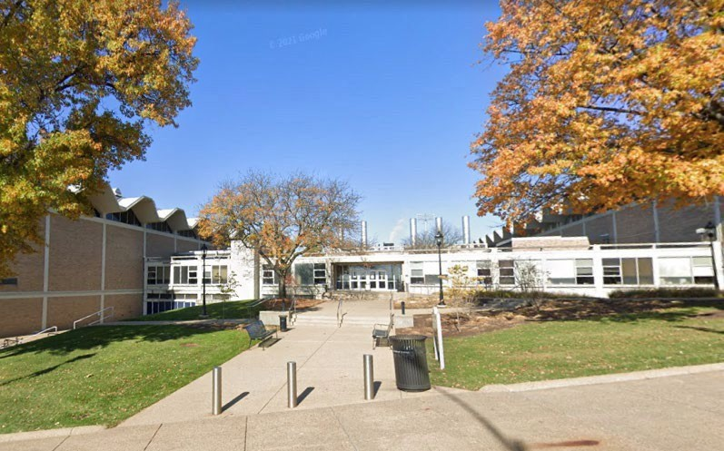
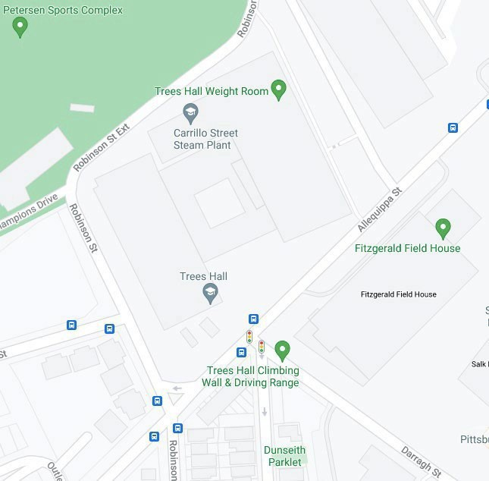
Visual Image: 5–16-year-old drop-off and pick-up location. This is Trees Hall Main Entrance located on Allequippa St, across from Fitzgerald Fieldhouse.
Blue Star: 5–16-year-old drop-off and pick-up location. This is Trees Hall Main Entrance.

